CHANGE THIS -
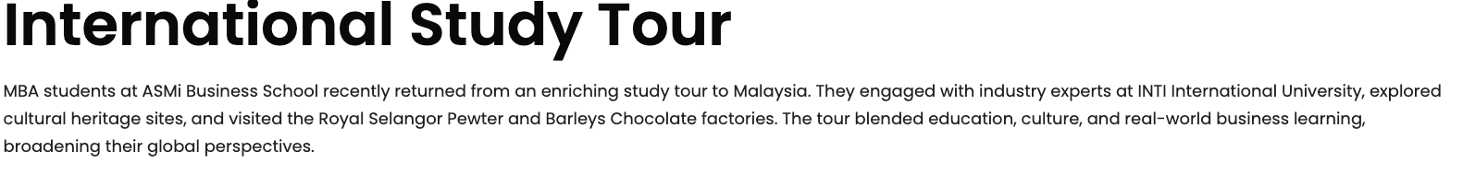
TO -
International Study Tours: Where Classrooms Go Global
At ASMi Business School, learning goes beyond campus. In 2024, MBA students explored Malaysia, engaging with experts at INTI International University and touring Royal Selangor Pewter and Barleys Chocolate. In 2025, the MBA 2nd-year cohort experienced Malaysia through global sessions at Universiti Malaya and APU, luxury insights at Bufori Motor Car Company, biotech innovation at LiGNO Biotech, and landmark visits to the Petronas Twin Towers and Putrajaya. Insightful, inspiring and fun, our tours shape globally minded leaders.
Add photos from this Photo drive - Asmi Malaysia 2025
Internships and Placements -

DRIVE LINK OF INTERNSHIP AND PLACEMENT -
DETAILS LINK - MBA 2nd Status of SIP : 2026
Photo of students - Internship Photo Drive

